LAB 2 Exercises

import numpy as np

import cv2

from google.colab.patches import cv2_imshow

img1=cv2.imread("Hapus_Mango.jpg")

cv2_imshow(img1)

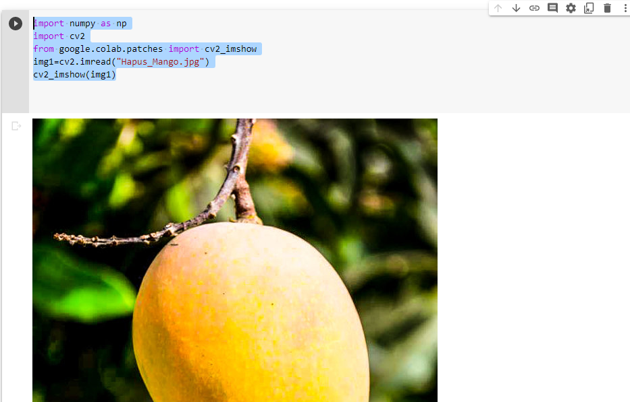

red=img1[:,:,0]

cv2_imshow(red)

green=img1[:,:,1]

cv2_imshow(green)

blue=img1[:,:,2]

cv2_imshow(blue)

plt.subplot(141)

plt.title("Original Image")

plt.xticks([]),plt.yticks([])

plt.imshow(img1)

plt.subplot(142)

plt.title("red")

plt.xticks([]),plt.yticks([])

plt.imshow(red)

plt.subplot(143)

plt.title("green")

plt.xticks([]),plt.yticks([])

plt.imshow(green)

plt.subplot(144)

plt.title("blue")

plt.xticks([]),plt.yticks([])

plt.imshow(blue)

import cv2

from google.colab.patches import cv2_imshow

img2 =cv2.imread("Hapus_Mango.jpg")

rgb_image=cv2.cvtColor(img2,cv2.COLOR_BGR2RGB)

cv2_imshow(rgb_image)

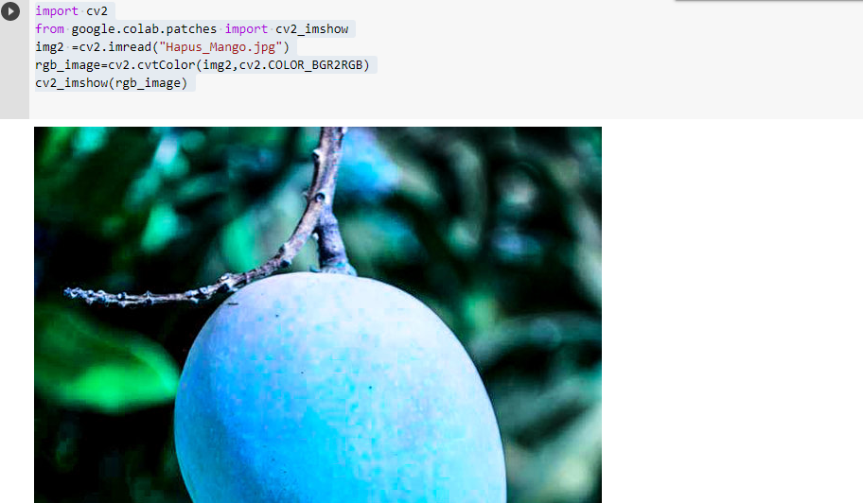

import cv2

import numpy as np

img2= cv2.imread("Hapus_Mango.jpg")

img2.shape

cropped = img2[10:100,10:150]

cv2_imshow(cropped)

import numpy as np

from google.colab.patches import cv2_imshow

img2=cv2.imread("Hapus_Mango.jpg")

cv2_imshow(img2)

img2=img2+100

cv2_imshow(img2)

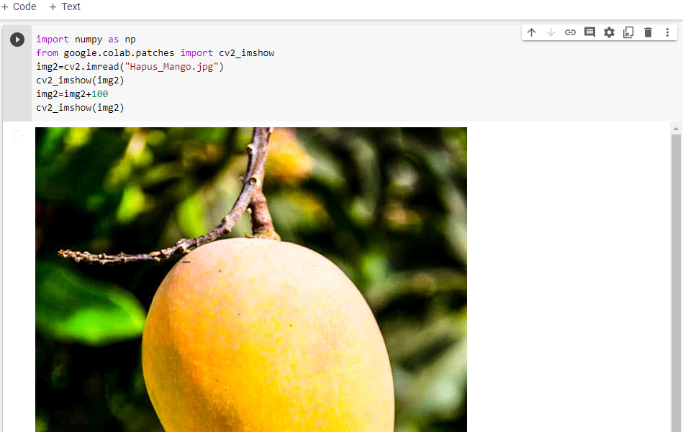

import numpy as np

import cv2

from google.colab.patches import cv2_imshow

img1=cv2.imread("blackandwhite.jpg")

cv2_imshow(img1)

neg=255-img1

cv2_imshow(neg)

import numpy as np

import cv2

from google.colab.patches import cv2_imshow

img=cv2.imread("blackandwhite.jpg")

cv2_imshow(img)

c=255/(np.log(1+np.max(img)))

img_log=c*np.log(1+img)

img_log=np.array(img_log,dtype=np.uint8)

cv2_imshow(img_log)

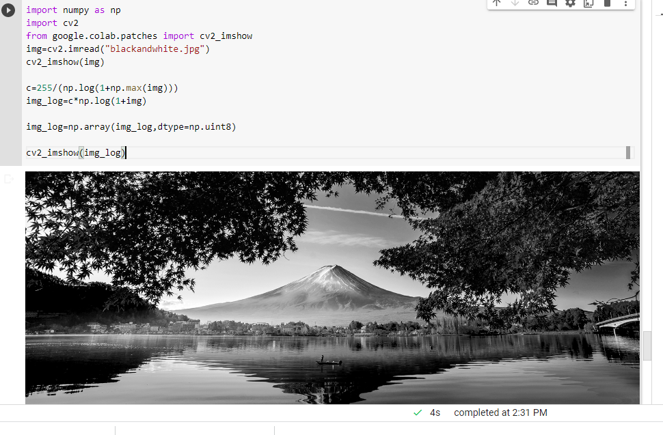

import numpy as np

import cv2

from google.colab.patches import cv2_imshow

img1=cv2.imread("blackandwhite.jpg")

cv2_imshow(img1)

im1=np.array(255*(img1/255) **0.6,dtype='uint8')

cv2_imshow(im1)

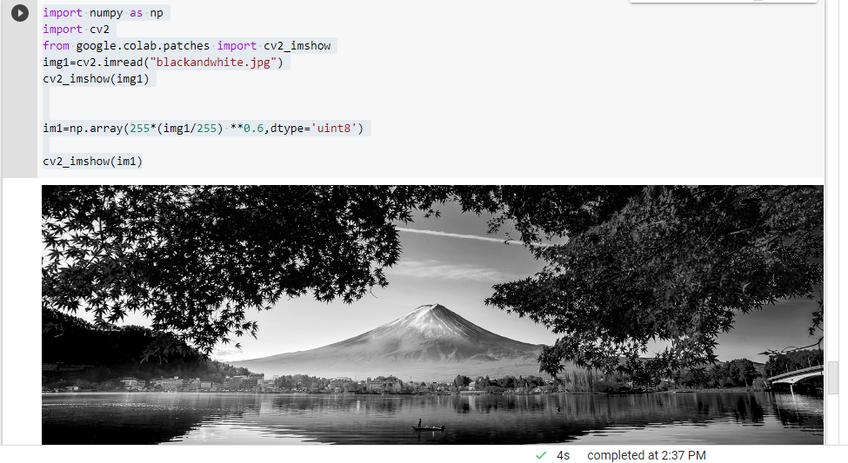

height, width,_=img2.shape

for i in range(0,height-1):

  for j in range(0,width-1):

    pixel=img2[i,j]

    #Negate each channel by subtrating it from 255

    #1st index contains red pixel

    pixel[0]=255-pixel[0]

    #2nd index contains green pixel

    pixel[1]=255-pixel[1]

    #3rd index contains blue pixel

    pixel[2]=255-pixel[2]

    #store new values in the pixel

    img2[i,j]=pixel

#Display the negative transformed image

plt.imshow(img2)

plt.show()

import cv2

from google.colab.patches import cv2_imshow

img=cv2.imread("card.jpg",0)

retval,threshold=cv2.threshold(img,62,255,cv2.THRESH_BINARY)

cv2_imshow( img)

cv2_imshow(threshold)

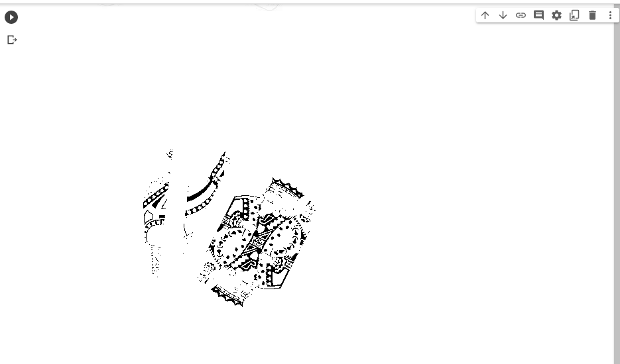

thresh=127

maxValue=255

th,dst=cv2.threshold(img,thresh,maxValue,cv2.THRESH_TRUNC);

plt.imshow(dst,cmap='gray')

plt.axis('off')

plt.show()

image=cv2.imread("light.jfif")

#to convert the image in greyscale

img=cv2.cvtColor(image,cv2.COLOR_BGR2GRAY)

ret,th1=cv2.threshold(img,160,255,cv2.THRESH_BINARY)

th2=cv2.adaptiveThreshold(img,255,cv2.ADAPTIVE_THRESH_MEAN_C,cv2.THRESH_BINARY,11,2)

th3=cv2.adaptiveThreshold(img,255,cv2.ADAPTIVE_THRESH_GAUSSIAN_C,cv2.THRESH_BINARY,11,2)

plt.subplot(141)

plt.title("Original Image")

plt.xticks([]),plt.yticks([])

plt.imshow(img,cmap='gray')

plt.subplot(142)

plt.title("binary")

plt.xticks([]),plt.yticks([])

plt.imshow(th1,cmap='gray')

plt.subplot(143)

plt.title("Mean Image")

plt.xticks([]),plt.yticks([])

plt.imshow(th2,cmap='gray')

plt.subplot(144)

plt.title("Gaussian Image")

plt.xticks([]),plt.yticks([])

plt.imshow(th3,cmap='gray')

